UG05 Signature Tablet

User Manual

- Product Components Description

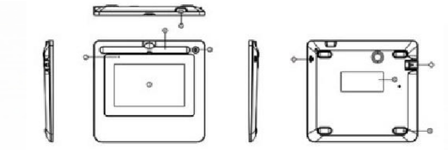
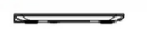

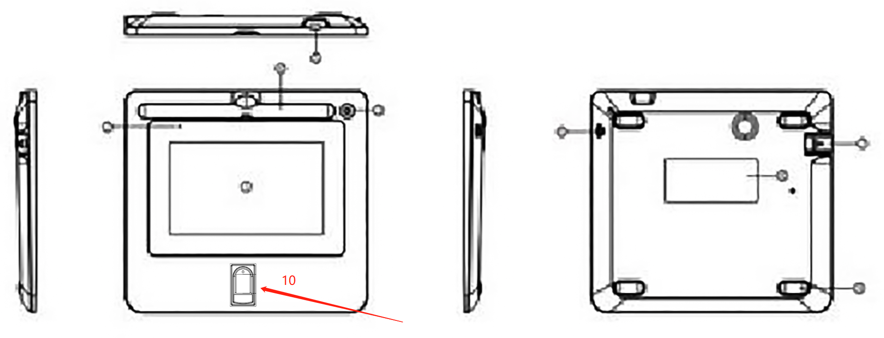

NO. | Component Name | Remark | NO. | Component Name | Remark
① | 5" screen |  | ② | Indicator light
③ | Pen socket |  | ④ | Pen slot
⑤ | Anti-theft lock hole |  | ⑥ | Pen lanyard hole
⑦ | USB cable cover |  | ⑧ | Certification sticker
⑨ | Anti-slip foot pad |  | ⑩ | Fingerprint sensor | Optional

- Packing List
NO. | Name | Quantity (piece)
1 | Signature Tablet | 1
2 | Electromagnetic pen | 1
3 | Pen nib | 3
4 | Pen nib clip | 1
5 | USB cable | 1
6 | Pen strap | 1
7 | Quick guide | 1
* If any accessories are found to be damaged or missing, please contact the supplier in time.

- Connect to Computer
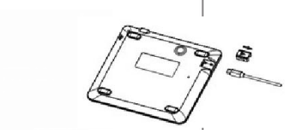
Open the USB cable cover on the back of the tablet, insert the USB plug, and then put the cover back.
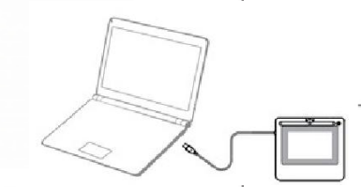
Insert the USB plug into the computer to complete the computer installation.

- Software Installation
Download software installation package under the website of https://business.hanvonugee.com/en

* If you have any technical questions, please contact us via signature.software@ugee.com.

